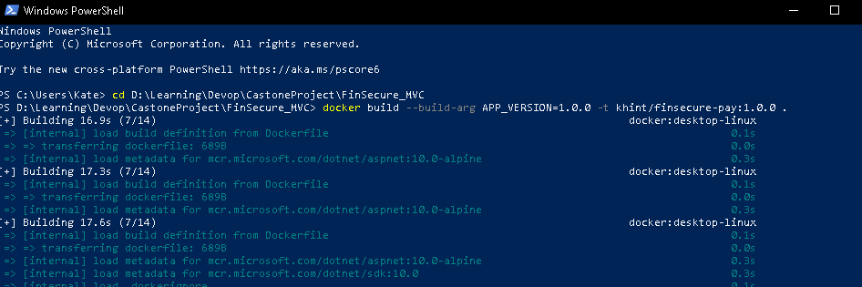

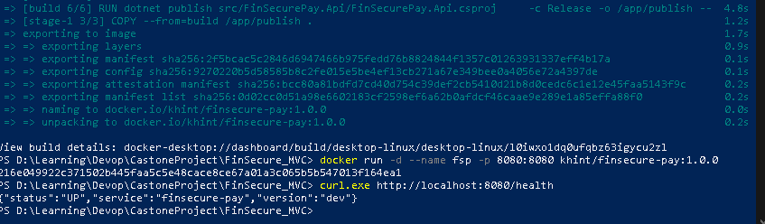
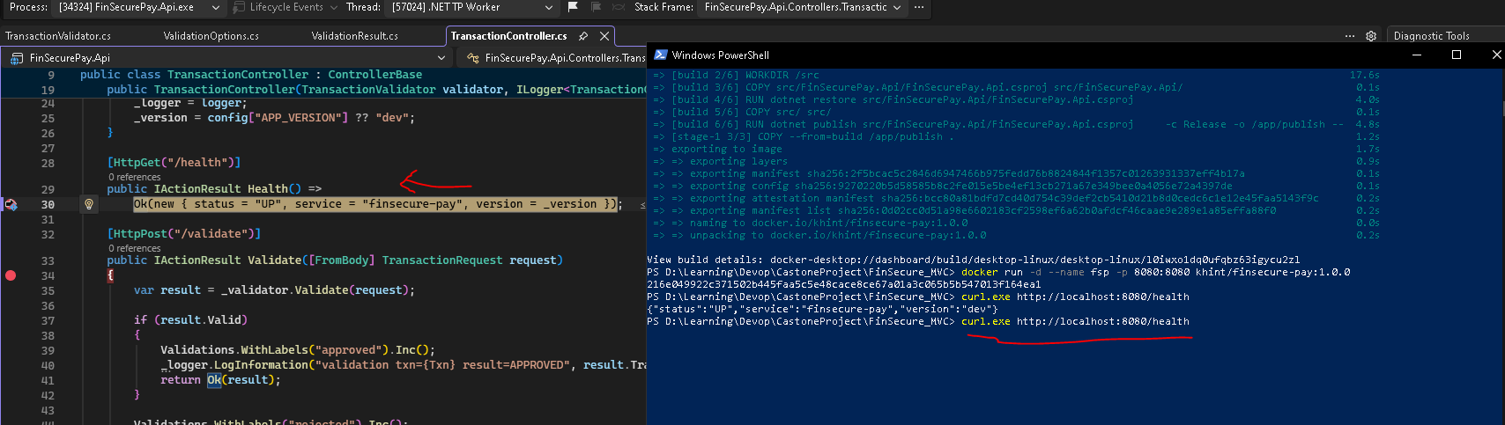
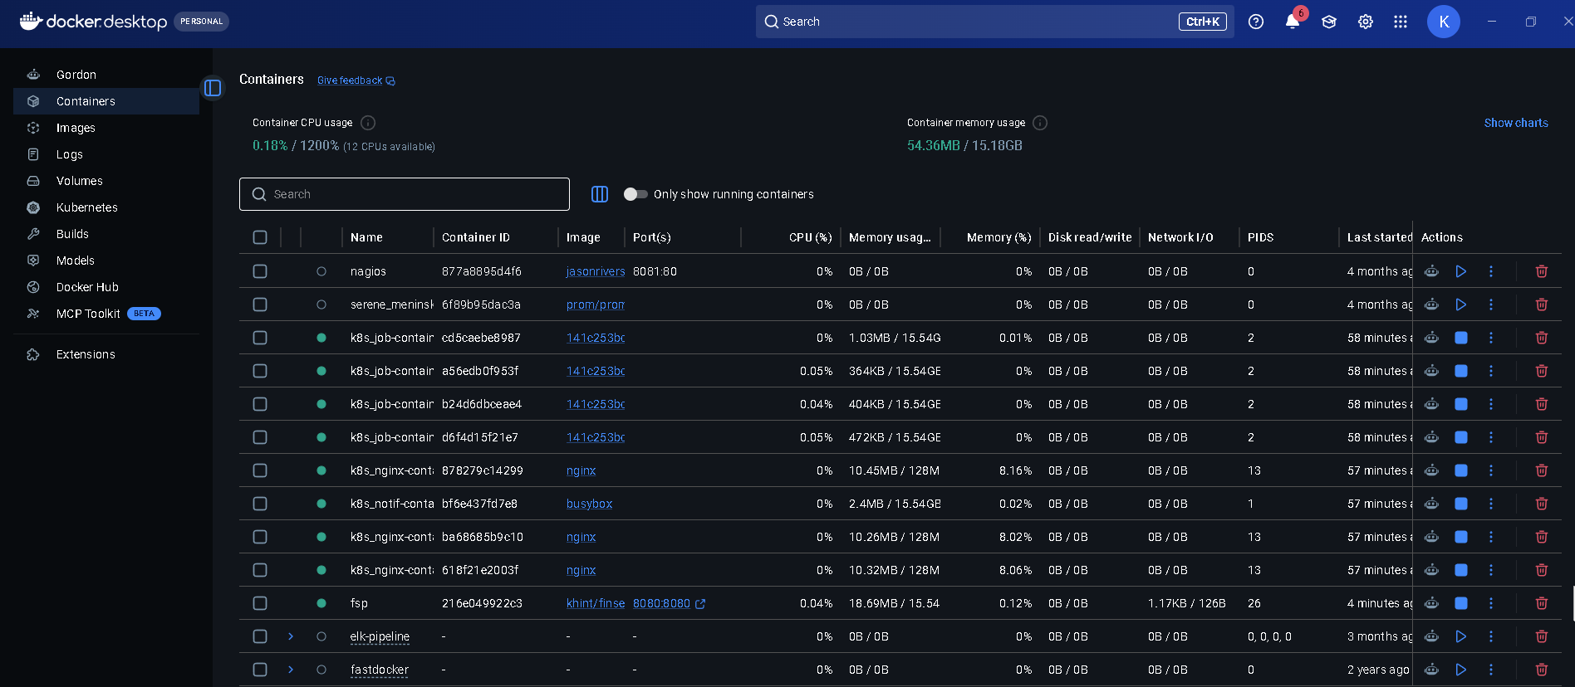

FinSecure Pay Capstone — Step-by-Step Guide (ASP.NET Core)
Oct 26, 2026 · @KHinT

Overview and setup
This guide builds the capstone with ASP.NET Core on .NET 10 instead of Spring Boot; everything from Docker onward (Jenkins, EKS, Trivy, Prometheus, Grafana, CloudWatch) is the same as the Java route. Use ASP.NET Core rather than classic ASP.NET MVC on .NET Framework: classic MVC only runs in Windows containers, which EKS supports only with extra Windows node groups and far less tooling.
Tool substitutions to justify in your design doc (the brief allows equivalents with justification):
Brief recommends | Used here | Justification
Spring Boot | ASP.NET Core Web API (controllers) | Team's existing C#/.NET skills; cross-platform, Linux-container ready, built-in health checks and DI
Maven | dotnet CLI + NuGet | The standard .NET build and dependency tool; restore, build, test, publish in one CLI
JUnit 5 | xUnit | The default .NET unit-test framework; same Arrange/Act/Assert style, JUnit XML output for Jenkins
OWASP Dependency-Check | dotnet list package --vulnerable + Trivy | Dependency-Check's .NET analyzer is limited; NuGet's audit uses the GitHub Advisory Database, and Trivy also scans the published .deps.json
Micrometer / Actuator | prometheus-net + ASP.NET Core health checks | The common .NET Prometheus exporter; health checks give separate liveness and readiness endpoints
Send your facilitator a one-line note confirming the .NET alternative before you start, in case approval is needed.
Install on your laptop: Git, .NET 10 SDK, Docker Desktop, AWS CLI v2, eksctl, kubectl, Helm 3, and Git Bash (curl/bash commands below assume Git Bash or WSL; dotnet commands work in PowerShell too). Visual Studio 2022/2026 or VS Code with C# Dev Kit is fine as the editor.
Accounts: GitHub (public repo), Docker Hub (access token), AWS, SonarQube Cloud (sign in with GitHub), and a Gmail address with an App Password for SMTP.
Repository layout you will end up with:
finsecure-pay/
├── FinSecurePay.slnx (or .sln)
├── Dockerfile
├── .dockerignore
├── Jenkinsfile
├── src/FinSecurePay.Api/
│ ├── FinSecurePay.Api.csproj
│ ├── Program.cs
│ ├── appsettings.json
│ ├── Controllers/TransactionController.cs
│ ├── Models/TransactionRequest.cs
│ ├── Models/ValidationResult.cs
│ ├── Services/ValidationOptions.cs
│ └── Services/TransactionValidator.cs
├── tests/FinSecurePay.Tests/
│ ├── FinSecurePay.Tests.csproj
│ └── TransactionValidatorTests.cs
├── k8s/ (namespace, configmap, deployment, service)
└── monitoring/ (values.yaml, servicemonitor.yaml, alert-rules.yaml, dashboard.json)
Suggested order:
- Day 1 — Task 1 app + tests, Task 2 Docker (local only, no cost).
- Day 2 — Task 3 EKS cluster + manifests.
- Day 3 — Task 4 Jenkins on EC2 + pipeline, then Task 5 security gates.
- Day 4 — Task 6 monitoring, alerting, email, logging.
- Day 5 — Task 7 design doc, slides, demo rehearsal, then tear everything down.
Cost warning: EKS bills the control plane hourly, plus worker nodes, the Jenkins EC2 instance and the load balancer. Stop Jenkins overnight, set an AWS Budget alert, and delete the cluster once your evidence and demo recording are done (teardown is in the last section).

Task 1 — Application and version control
Goal: an ASP.NET Core Web API with GET /health and POST /validate, six validation rules, xUnit tests passing, pushed to GitHub.

1.1 Scaffold the solution
mkdir finsecure-pay && cd finsecure-pay
dotnet new sln -n FinSecurePay
dotnet new webapi --use-controllers -n FinSecurePay.Api -o src/FinSecurePay.Api
dotnet new xunit -n FinSecurePay.Tests -o tests/FinSecurePay.Tests
dotnet sln add src/FinSecurePay.Api tests/FinSecurePay.Tests
dotnet add tests/FinSecurePay.Tests reference src/FinSecurePay.Api
dotnet add src/FinSecurePay.Api package prometheus-net.AspNetCore
dotnet add tests/FinSecurePay.Tests package JunitXml.TestLogger
dotnet new gitignore
Delete the template's WeatherForecast.cs, Controllers/WeatherForecastController.cs, the .http file and tests/FinSecurePay.Tests/UnitTest1.cs. JunitXml.TestLogger lets Jenkins read the test results later.

1.2 Validation rules (put these in your slides)
# | Rule | Rejection reason
1 | TransactionId and AccountId are present | MISSING_FIELDS
2 | AccountId matches ACC + 6 digits | INVALID_ACCOUNT_FORMAT
3 | Amount is greater than 0 | NON_POSITIVE_AMOUNT
4 | Amount does not exceed the configured limit (default 10,000) | AMOUNT_OVER_LIMIT
5 | Currency is in the allowed list (default SGD, USD, EUR) | UNSUPPORTED_CURRENCY
6 | Merchant category is not blocked (GAMBLING, CRYPTO_ATM) | BLOCKED_MERCHANT
The limit and currency list come from configuration (appsettings.json, overridden by environment variables), which is what the Kubernetes ConfigMap changes in Task 3.

1.3 Source files (all under src/FinSecurePay.Api/)
Models/TransactionRequest.cs
namespace FinSecurePay.Api.Models;
public record TransactionRequest(
string? TransactionId,
string? AccountId,
decimal? Amount,
string? Currency,
string? MerchantCategory);
Models/ValidationResult.cs
namespace FinSecurePay.Api.Models;
public record ValidationResult(string? TransactionId, bool Valid, IReadOnlyList<string> Reasons);
Services/ValidationOptions.cs
namespace FinSecurePay.Api.Services;
public class ValidationOptions
{
public decimal MaxAmount { get; set; } = 10000m;
public string AllowedCurrencies { get; set; } = "SGD,USD,EUR";
}
Services/TransactionValidator.cs
using System.Text.RegularExpressions;
using FinSecurePay.Api.Models;
namespace FinSecurePay.Api.Services;
public class TransactionValidator
{
private static readonly Regex AccountPattern = new("^ACC[0-9]{6}$", RegexOptions.Compiled);
private static readonly HashSet<string> BlockedMerchants =
new(StringComparer.OrdinalIgnoreCase) { "GAMBLING", "CRYPTO_ATM" };
private readonly decimal _maxAmount;
private readonly HashSet<string> _allowedCurrencies;
public TransactionValidator(decimal maxAmount, IEnumerable<string> allowedCurrencies)
{
_maxAmount = maxAmount;
_allowedCurrencies = new HashSet<string>(allowedCurrencies, StringComparer.OrdinalIgnoreCase);
}
public ValidationResult Validate(TransactionRequest tx)
{
var reasons = new List<string>();
if (string.IsNullOrWhiteSpace(tx.TransactionId) || string.IsNullOrWhiteSpace(tx.AccountId))
reasons.Add("MISSING_FIELDS");
else if (!AccountPattern.IsMatch(tx.AccountId))
reasons.Add("INVALID_ACCOUNT_FORMAT");
if (tx.Amount is null || tx.Amount <= 0)
reasons.Add("NON_POSITIVE_AMOUNT");
else if (tx.Amount > _maxAmount)
reasons.Add("AMOUNT_OVER_LIMIT");
if (string.IsNullOrWhiteSpace(tx.Currency) || !_allowedCurrencies.Contains(tx.Currency))
reasons.Add("UNSUPPORTED_CURRENCY");
if (!string.IsNullOrWhiteSpace(tx.MerchantCategory) && BlockedMerchants.Contains(tx.MerchantCategory))
reasons.Add("BLOCKED_MERCHANT");
return new ValidationResult(tx.TransactionId, reasons.Count == 0, reasons);
}
}
Controllers/TransactionController.cs — also counts approved/rejected results for Grafana and logs each decision for Task 6.
using FinSecurePay.Api.Models;
using FinSecurePay.Api.Services;
using Microsoft.AspNetCore.Mvc;
using Prometheus;
namespace FinSecurePay.Api.Controllers;
[ApiController]
public class TransactionController : ControllerBase
{
private static readonly Counter Validations = Metrics.CreateCounter(
"finsecure_validations_total", "Transaction validations by result", "result");
private readonly TransactionValidator _validator;
private readonly ILogger<TransactionController> _logger;
private readonly string _version;
public TransactionController(TransactionValidator validator,
ILogger<TransactionController> logger,
IConfiguration config)
{
_validator = validator;
_logger = logger;
_version = config["APP_VERSION"] ?? "dev";
}
[HttpGet("/health")]
public IActionResult Health() =>
Ok(new { status = "UP", service = "finsecure-pay", version = _version });
[HttpPost("/validate")]
public IActionResult Validate([FromBody] TransactionRequest request)
{
var result = _validator.Validate(request);
if (result.Valid)
{
Validations.WithLabels("approved").Inc();
_logger.LogInformation("validation txn={Txn} result=APPROVED", result.TransactionId);
return Ok(result);
}
Validations.WithLabels("rejected").Inc();
_logger.LogWarning("validation txn={Txn} result=REJECTED reasons={Reasons}",
result.TransactionId, string.Join(",", result.Reasons));
return UnprocessableEntity(result);
}
}
Program.cs — replace the template version entirely (no HTTPS redirect: TLS ends at the load balancer).
using FinSecurePay.Api.Services;
using Microsoft.AspNetCore.Diagnostics.HealthChecks;
using Microsoft.Extensions.Options;
using Prometheus;
var builder = WebApplication.CreateBuilder(args);
builder.Logging.AddSimpleConsole(o =>
{
o.SingleLine = true;
o.TimestampFormat = "yyyy-MM-ddTHH:mm:ss ";
});
builder.Services.Configure<ValidationOptions>(builder.Configuration.GetSection("Validation"));
builder.Services.AddSingleton(sp =>
{
var o = sp.GetRequiredService<IOptions<ValidationOptions>>().Value;
var currencies = o.AllowedCurrencies.Split(',',
StringSplitOptions.RemoveEmptyEntries | StringSplitOptions.TrimEntries);
return new TransactionValidator(o.MaxAmount, currencies);
});
builder.Services.AddControllers();
builder.Services.AddHealthChecks();
var app = builder.Build();
app.UseRouting();
app.UseHttpMetrics(); // request count + latency metrics
app.MapControllers();
app.MapHealthChecks("/health/live", new HealthCheckOptions { Predicate = _ => false });
app.MapHealthChecks("/health/ready");
app.MapMetrics(); // GET /metrics for Prometheus
app.Run();
public partial class Program { }
appsettings.json
{
"Logging": {
"LogLevel": {
"Default": "Information",
"Microsoft.AspNetCore": "Warning"
}
},
"AllowedHosts": "*",
"Validation": {
"MaxAmount": 10000,
"AllowedCurrencies": "SGD,USD,EUR"
}
}
In Kubernetes the environment variables Validation__MaxAmount and Validation__AllowedCurrencies (double underscore) override these values.

1.4 Unit tests (xUnit)
tests/FinSecurePay.Tests/TransactionValidatorTests.cs — tests the validator directly, no web host, so they are fast and stable.
using FinSecurePay.Api.Models;
using FinSecurePay.Api.Services;
namespace FinSecurePay.Tests;
public class TransactionValidatorTests
{
private readonly TransactionValidator _validator =
new(10000m, new[] { "SGD", "USD", "EUR" });
private static TransactionRequest Tx(string? acc, decimal? amount, string? ccy, string? merchant) =>
new("TXN-1", acc, amount, ccy, merchant);
[Fact]
public void ValidTransaction_IsApproved()
{
var r = _validator.Validate(Tx("ACC123456", 250m, "SGD", "RETAIL"));
Assert.True(r.Valid);
Assert.Empty(r.Reasons);
}
[Fact]
public void MissingAccount_IsRejected() =>
Assert.Contains("MISSING_FIELDS", _validator.Validate(Tx(null, 10m, "SGD", "RETAIL")).Reasons);
[Fact]
public void BadAccountFormat_IsRejected() =>
Assert.Contains("INVALID_ACCOUNT_FORMAT", _validator.Validate(Tx("12345", 10m, "SGD", "RETAIL")).Reasons);
[Theory]
[InlineData(0.0)]
[InlineData(-5.0)]
public void ZeroOrNegativeAmount_IsRejected(double amount) =>
Assert.Contains("NON_POSITIVE_AMOUNT",
_validator.Validate(Tx("ACC123456", (decimal)amount, "SGD", "RETAIL")).Reasons);
[Fact]
public void AmountOverLimit_IsRejected() =>
Assert.Contains("AMOUNT_OVER_LIMIT", _validator.Validate(Tx("ACC123456", 10000.01m, "SGD", "RETAIL")).Reasons);
[Fact]
public void AmountAtLimit_IsApproved() =>
Assert.True(_validator.Validate(Tx("ACC123456", 10000m, "USD", "RETAIL")).Valid);
[Fact]
public void UnsupportedCurrency_IsRejected() =>
Assert.Contains("UNSUPPORTED_CURRENCY", _validator.Validate(Tx("ACC123456", 10m, "JPY", "RETAIL")).Reasons);
[Fact]
public void BlockedMerchant_IsRejected() =>
Assert.Contains("BLOCKED_MERCHANT", _validator.Validate(Tx("ACC123456", 10m, "SGD", "gambling")).Reasons);
[Fact]
public void MultipleFailures_AreAllReported()
{
var r = _validator.Validate(Tx("BAD", 0m, "XYZ", "GAMBLING"));
Assert.False(r.Valid);
Assert.Equal(4, r.Reasons.Count);
}
}

1.5 Build, run and test locally
dotnet build
dotnet test # expect: Passed! Failed: 0, Passed: 10
dotnet run --project src/FinSecurePay.Api --urls http://localhost:8080
# in a second terminal (Git Bash)
curl http://localhost:8080/health
curl http://localhost:8080/health/ready
curl -X POST http://localhost:8080/validate -H "Content-Type: application/json" \
-d '{"transactionId":"TXN-1","accountId":"ACC123456","amount":250,"currency":"SGD","merchantCategory":"RETAIL"}'
curl -X POST http://localhost:8080/validate -H "Content-Type: application/json" \
-d '{"transactionId":"TXN-2","accountId":"ACC123456","amount":50000,"currency":"JPY","merchantCategory":"GAMBLING"}'
curl http://localhost:8080/metrics | grep finsecure
The first validate call returns 200 with "valid": true; the second returns 422 with three reasons.

1.6 Push to GitHub
git init -b main
git add .
git commit -m "Task 1: ASP.NET Core transaction validation API with xUnit tests"
git remote add origin https://github.com/<you>/finsecure-pay.git
git push -u origin main
In GitHub, open Settings → Code security and turn on secret scanning and push protection.
Evidence: repo link; dotnet test output (10 passed, 0 failed); the two curl responses; the commit history.

Task 2 — Containerisation
Goal: a small, non-root Linux image tagged with a real version, running locally and pushed to Docker Hub.

2.1 Dockerfile (multi-stage, in the repo root)
# ---- build stage ----
FROM mcr.microsoft.com/dotnet/sdk:10.0 AS build
WORKDIR /src
COPY src/FinSecurePay.Api/FinSecurePay.Api.csproj src/FinSecurePay.Api/
RUN dotnet restore src/FinSecurePay.Api/FinSecurePay.Api.csproj
COPY src/ src/
RUN dotnet publish src/FinSecurePay.Api/FinSecurePay.Api.csproj \
-c Release -o /app/publish --no-restore
# ---- runtime stage ----
FROM mcr.microsoft.com/dotnet/aspnet:10.0-alpine
ARG APP_VERSION=dev
ENV APP_VERSION=${APP_VERSION}
WORKDIR /app
COPY --from=build /app/publish .
USER $APP_UID
EXPOSE 8080
ENTRYPOINT ["dotnet", "FinSecurePay.Api.dll"]
Design points for your slides: the SDK stays in the build stage, so the final image only has the ASP.NET runtime; the Alpine runtime image is small and gives Trivy less to flag; USER $APP_UID runs as the built-in non-root app user; .NET 8+ images already listen on port 8080. Copying the .csproj first lets Docker cache the restore layer, so rebuilds after a code change are fast.
.dockerignore
**/bin/
**/obj/
tests/
.git/
.vs/
*.md

2.2 Build, run and test
docker build --build-arg APP_VERSION=1.0.0 -t <dockerhub-user>/finsecure-pay:1.0.0 .
docker images | grep finsecure-pay
docker run -d --name fsp -p 8080:8080 <dockerhub-user>/finsecure-pay:1.0.0
docker ps
curl http://localhost:8080/health # {"status":"UP",...,"version":"1.0.0"}
curl http://localhost:8080/health/ready # Healthy
docker exec fsp whoami # app (not root)
docker logs fsp

2.3 Push to Docker Hub
docker login -u <dockerhub-user> # paste the access token when asked
docker push <dockerhub-user>/finsecure-pay:1.0.0
docker stop fsp && docker rm fsp
Use fixed version tags and never deploy latest — a fixed tag is what makes rollback reliable. From Task 4 onward Jenkins tags images as 1.0.<build number>.
Evidence: Dockerfile; docker images with tag and size; docker ps, /health response and whoami; the Docker Hub page showing tag 1.0.0.

Task 3 — Kubernetes on Amazon EKS
Goal: two healthy replicas behind a public load balancer, configured by a ConfigMap, guarded by probes, and recreated automatically when a pod dies.

3.1 Create the cluster (about 15–20 minutes)
aws configure # region ap-southeast-1
eksctl create cluster \
--name finsecure \
--region ap-southeast-1 \
--nodegroup-name workers \
--node-type t3.medium \
--nodes 2 --nodes-min 2 --nodes-max 3 \
--managed
kubectl get nodes # two Linux nodes, STATUS Ready

3.2 Manifests (in the k8s/ folder)
k8s/namespace.yaml
apiVersion: v1
kind: Namespace
metadata:
name: finsecure
k8s/configmap.yaml — the double underscore maps to the Validation section of appsettings.json.
apiVersion: v1
kind: ConfigMap
metadata:
name: finsecure-config
namespace: finsecure
data:
Validation__MaxAmount: "10000"
Validation__AllowedCurrencies: "SGD,USD,EUR"
ASPNETCORE_ENVIRONMENT: "Production"
k8s/deployment.yaml
apiVersion: apps/v1
kind: Deployment
metadata:
name: finsecure-pay
namespace: finsecure
labels:
app: finsecure-pay
spec:
replicas: 2
revisionHistoryLimit: 10
selector:
matchLabels:
app: finsecure-pay
strategy:
type: RollingUpdate
rollingUpdate:
maxUnavailable: 0
maxSurge: 1
template:
metadata:
labels:
app: finsecure-pay
spec:
securityContext:
runAsNonRoot: true
containers:
- name: app
image: <dockerhub-user>/finsecure-pay:1.0.0
imagePullPolicy: IfNotPresent
ports:
- name: http
containerPort: 8080
envFrom:
- configMapRef:
name: finsecure-config
resources:
requests:
cpu: 100m
memory: 128Mi
limits:
cpu: 500m
memory: 256Mi
readinessProbe:
httpGet:
path: /health/ready
port: http
initialDelaySeconds: 5
periodSeconds: 5
failureThreshold: 3
livenessProbe:
httpGet:
path: /health/live
port: http
initialDelaySeconds: 15
periodSeconds: 10
failureThreshold: 3
k8s/service.yaml
apiVersion: v1
kind: Service
metadata:
name: finsecure-pay
namespace: finsecure
labels:
app: finsecure-pay
spec:
type: LoadBalancer
selector:
app: finsecure-pay
ports:
- name: http
port: 80
targetPort: http
Why these choices: maxUnavailable: 0 keeps both replicas serving during a rollout; readiness keeps traffic away from a pod that is still starting; liveness restarts a pod that hangs; runAsNonRoot works because the image runs as the numeric $APP_UID; the named port http and the app label are what Prometheus uses in Task 6. .NET starts quickly, so the probe delays are shorter than for a JVM app.

3.3 Deploy and verify
kubectl apply -f k8s/namespace.yaml
kubectl apply -f k8s/
kubectl -n finsecure rollout status deployment/finsecure-pay
kubectl -n finsecure get pods -o wide # 2 pods, READY 1/1
kubectl -n finsecure describe pod <pod> # shows Liveness and Readiness lines
kubectl -n finsecure get configmap finsecure-config -o yaml
kubectl -n finsecure get svc finsecure-pay # copy EXTERNAL-IP (an ELB hostname)
curl http://<EXTERNAL-IP>/health # may take 2–3 minutes for DNS

3.4 Show the ConfigMap working (optional, good for the demo)
kubectl -n finsecure patch configmap finsecure-config -p '{"data":{"Validation__MaxAmount":"5000"}}'
kubectl -n finsecure rollout restart deployment/finsecure-pay
# a 6000 SGD transaction is now rejected with AMOUNT_OVER_LIMIT; set it back afterwards

3.5 Automatic recovery
# terminal 1
kubectl -n finsecure get pods -w
# terminal 2
kubectl -n finsecure delete pod <one-pod-name>
Terminal 1 shows the old pod Terminating and a new pod going Pending → Running → Ready, with the ReplicaSet back at 2. kubectl -n finsecure get events --sort-by=.lastTimestamp gives a second screenshot.
Evidence: the four YAML files; get pods with 2/2 Ready; describe pod probe lines; get svc plus the curl result on the ELB address; the watch output during the pod delete.

Task 4 — CI/CD with Jenkins
Goal: every push runs Checkout → Build → Test → Package → Security Checks → Container Build → Image Scan → Push → Deploy; a failing test stops it before anything ships.

4.1 Jenkins server on EC2
- Launch an EC2 instance: Ubuntu 24.04, t3.medium, 30 GB gp3, same region. Security group: ports 22 and 8080 from your IP only (add GitHub's webhook ranges on 8080 if you use webhooks).
- Create an IAM role for the instance with a small inline policy allowing only eks:DescribeCluster on your cluster — that is all aws eks update-kubeconfig needs. Attach it to the instance, so there are no access keys on the server.
- On the instance install Java 21 (Jenkins needs it, and so does the Sonar scanner), Docker, Jenkins, AWS CLI v2, kubectl, Trivy and the .NET 10 SDK. Follow jenkins.io, Trivy's install page and Microsoft's "Install .NET on Ubuntu" page for the repository steps, then:
sudo apt update && sudo apt install -y openjdk-21-jre docker.io unzip
# ... install jenkins, awscli v2, kubectl, trivy and dotnet-sdk-10.0 per their docs ...
sudo usermod -aG docker jenkins
sudo -u jenkins dotnet tool install --global dotnet-sonarscanner
sudo systemctl restart jenkins
sudo cat /var/lib/jenkins/secrets/initialAdminPassword
- Give the IAM role access to the cluster, limited to the app namespace (a least-privilege point for the design doc):
aws eks create-access-entry --cluster-name finsecure \
--principal-arn arn:aws:iam::<account-id>:role/<jenkins-role>
aws eks associate-access-policy --cluster-name finsecure \
--principal-arn arn:aws:iam::<account-id>:role/<jenkins-role> \
--policy-arn arn:aws:eks::aws:cluster-access-policy/AmazonEKSEditPolicy \
--access-scope type=namespace,namespaces=finsecure
- Open http://<ec2-ip>:8080, install suggested plugins, then add: Docker Pipeline, Pipeline: Stage View, Email Extension, JUnit, GitHub.
- Manage Jenkins → Credentials → add dockerhub-creds (username + access token) and sonar-token (secret text).

4.2 Create the job
New Item → Pipeline → "finsecure-pay". Under Build Triggers tick GitHub hook trigger for GITScm polling. Under Pipeline choose Pipeline script from SCM, Git, your repo URL, branch */main, script path Jenkinsfile. In GitHub: Settings → Webhooks → http://<ec2-ip>:8080/github-webhook/, content type JSON. If webhooks are awkward, use Poll SCM with H/2 * * * * — it still counts as triggered by a code change.

4.3 Jenkinsfile
Replace <dockerhub-user>, the Sonar organisation/key and the email address.
pipeline {
agent any
environment {
IMAGE = '<dockerhub-user>/finsecure-pay'
VERSION = "1.0.${env.BUILD_NUMBER}"
CLUSTER = 'finsecure'
REGION = 'ap-southeast-1'
NOTIFY = 'you@gmail.com'
DOTNET_CLI_TELEMETRY_OPTOUT = '1'
DOTNET_NOLOGO = '1'
PATH = "/var/lib/jenkins/.dotnet/tools:${env.PATH}"
}
options {
timestamps()
disableConcurrentBuilds()
buildDiscarder(logRotator(numToKeepStr: '20'))
}
stages {
stage('Checkout') {
steps { checkout scm }
}
stage('Build') {
steps {
sh 'dotnet restore'
sh 'dotnet build -c Release --no-restore'
}
}
stage('Test') {
steps {
sh 'dotnet test -c Release --no-build --logger "junit;LogFilePath=$WORKSPACE/test-results/junit.xml"'
}
post { always { junit 'test-results/*.xml' } }
}
stage('Package') {
steps {
sh 'dotnet publish src/FinSecurePay.Api/FinSecurePay.Api.csproj -c Release -o publish --no-build'
}
}
stage('Security Checks') {
stages {
stage('Code Quality (SonarQube Cloud)') {
steps {
withCredentials([string(credentialsId: 'sonar-token', variable: 'SONAR_TOKEN')]) {
sh '''
dotnet sonarscanner begin /k:"<your-project-key>" /o:"<your-sonar-org>" \
/d:sonar.host.url="https://sonarcloud.io" \
/d:sonar.token="$SONAR_TOKEN" \
/d:sonar.qualitygate.wait=true
dotnet build -c Release --no-restore
dotnet sonarscanner end /d:sonar.token="$SONAR_TOKEN"
'''
}
}
}
stage('Dependency Audit (NuGet)') {
steps {
sh '''
dotnet list src/FinSecurePay.Api/FinSecurePay.Api.csproj package \
--vulnerable --include-transitive | tee nuget-audit.txt
if grep -qE "High|Critical" nuget-audit.txt; then
echo "BLOCKED: High/Critical vulnerable NuGet package found"
exit 1
fi
'''
}
post { always { archiveArtifacts artifacts: 'nuget-audit.txt', allowEmptyArchive: true } }
}
}
}
stage('Container Build') {
steps { sh 'docker build --build-arg APP_VERSION=$VERSION -t $IMAGE:$VERSION .' }
}
stage('Image Scan') {
steps {
sh '''trivy image --severity CRITICAL,HIGH --ignore-unfixed \
--exit-code 1 --format table --output trivy-report.txt $IMAGE:$VERSION'''
}
post { always { archiveArtifacts artifacts: 'trivy-report.txt', allowEmptyArchive: true } }
}
stage('Push') {
steps {
withCredentials([usernamePassword(credentialsId: 'dockerhub-creds',
usernameVariable: 'DH_USER', passwordVariable: 'DH_TOKEN')]) {
sh 'echo "$DH_TOKEN" | docker login -u "$DH_USER" --password-stdin'
sh 'docker push $IMAGE:$VERSION'
}
}
post { always { sh 'docker logout || true' } }
}
stage('Deploy') {
steps {
sh '''
aws eks update-kubeconfig --name $CLUSTER --region $REGION
kubectl -n finsecure set image deployment/finsecure-pay app=$IMAGE:$VERSION
kubectl -n finsecure annotate deployment/finsecure-pay \
kubernetes.io/change-cause="Jenkins build $BUILD_NUMBER image $VERSION" --overwrite
kubectl -n finsecure rollout status deployment/finsecure-pay --timeout=180s
'''
}
post {
failure { sh 'kubectl -n finsecure rollout undo deployment/finsecure-pay || true' }
}
}
}
post {
success {
emailext to: env.NOTIFY,
subject: "SUCCESS: ${env.JOB_NAME} #${env.BUILD_NUMBER} deployed ${env.VERSION}",
body: "Version ${env.VERSION} is live on EKS.\n${env.BUILD_URL}"
}
failure {
emailext to: env.NOTIFY,
subject: "FAILED: ${env.JOB_NAME} #${env.BUILD_NUMBER}",
body: "The pipeline failed and nothing was deployed.\nConsole: ${env.BUILD_URL}console",
attachLog: true
}
}
}

4.4 Demonstrations
- Triggered run: change something small (for example the service text in /health), commit, push. Screenshot the build starting by itself and the Stage View all green.
- Failed test blocks deployment: in MultipleFailures_AreAllReported, change Assert.Equal(4, ...) to Assert.Equal(5, ...), commit, push. Screenshot: Test stage red, all later stages skipped, the failed test in the Jenkins test report, kubectl -n finsecure get deploy -o wide still showing the previous image, and the failure email. Then revert the commit.
- Rollout of a new version: after a green build, run kubectl -n finsecure rollout history deployment/finsecure-pay and curl http://<EXTERNAL-IP>/health to show the new version.
- Rollback:
kubectl -n finsecure rollout history deployment/finsecure-pay
kubectl -n finsecure rollout undo deployment/finsecure-pay --to-revision=<good-revision>
kubectl -n finsecure rollout status deployment/finsecure-pay
curl http://<EXTERNAL-IP>/health # version shows the known-good tag again
The post { failure { rollout undo } } on the Deploy stage also rolls back automatically if a new version never becomes Ready — worth a line in the design doc.
Evidence: Jenkinsfile; green Stage View; red Stage View for the failed test with skipped stages; rollout history and /health before/after; rollback output.

Task 5 — DevSecOps
Goal: three automated checks with hard gates, one deliberately blocked build, its fix, and no secret anywhere in Git.

5.1 The three checks and their gates
Check | Tool | Gate that fails the pipeline
Code quality / static analysis | SonarQube Cloud via SonarScanner for .NET | Quality Gate is not Passed (sonar.qualitygate.wait=true)
Dependency vulnerabilities | dotnet list package --vulnerable --include-transitive | Any package with High or Critical severity
Container image (OS packages + the app's .deps.json) | Trivy | Any fixable HIGH or CRITICAL finding (--exit-code 1)
SonarQube Cloud setup: sign in at sonarcloud.io with GitHub, import the repo, then under Administration → Analysis Method turn off Automatic Analysis (Jenkins runs it, and C# needs a build-based scan anyway). My Account → Security → generate a token and save it in Jenkins as sonar-token. Copy the organisation and project key into the Jenkinsfile. The built-in "Sonar way" quality gate is fine.

5.2 Introduce a controlled high-severity finding
On a single commit, add an old Newtonsoft.Json with a known High advisory (CVE-2024-21907, fixed in 13.0.1):
dotnet add src/FinSecurePay.Api package Newtonsoft.Json --version 12.0.3
git commit -am "Demo: add vulnerable Newtonsoft.Json 12.0.3" && git push
Expected: the Dependency Audit stage prints Newtonsoft.Json 12.0.3 with severity High and fails; Container Build / Push / Deploy are skipped and the failure email arrives. Screenshot the console lines and the archived nuget-audit.txt. Locally, dotnet build also shows a NuGet audit warning (NU1903) for the same package — a nice extra screenshot.

5.3 Remediate
Upgrade or remove it (the app does not use it):
dotnet add src/FinSecurePay.Api package Newtonsoft.Json --version 13.0.3
# or: dotnet remove src/FinSecurePay.Api package Newtonsoft.Json
git commit -am "Fix CVE-2024-21907: upgrade Newtonsoft.Json" && git push
Capture the next fully green build and the clean audit. If Trivy ever blocks on the base image instead, rebuild with the latest aspnet:10.0-alpine patch tag — a second, realistic remediation example.

5.4 Secrets and credentials
- Jenkins: the Docker Hub token and Sonar token live only in Jenkins Credentials and are used through withCredentials, so they appear as **** in logs. Screenshot the Credentials page (IDs only) and a masked log line.
- AWS: Jenkins uses an IAM instance role and an EKS access entry scoped to the finsecure namespace — no access keys stored anywhere.
- Application config: appsettings.json holds only non-secret settings. Never commit appsettings.Development.json with real values; use dotnet user-secrets locally if you ever need one.
- Kubernetes: create runtime secrets from the command line, never from committed YAML:
kubectl -n finsecure create secret generic finsecure-secrets \
--from-literal=Security__ApiSigningKey="$(openssl rand -hex 32)"
kubectl -n finsecure get secrets # shows it exists, not its value
Add it to the Deployment next to the ConfigMap with envFrom: - secretRef: name: finsecure-secrets; ASP.NET Core then reads it as Security:ApiSigningKey. For the design doc, note that EKS can encrypt Secrets with a KMS key and that AWS Secrets Manager or Vault would be the production step up.
- GitHub: .gitignore (from dotnet new gitignore) excludes bin/, obj/ and .vs/; secret scanning and push protection are on.
Evidence: Sonar dashboard with Quality Gate Passed; nuget-audit.txt and Trivy reports; the blocked build (red stage + package and CVE in the log); the remediation commit and green build; Credentials page; kubectl get secrets output.

Task 6 — Monitoring, alerting and logging
Goal: Prometheus scrapes the app's /metrics and the cluster, Grafana shows live panels, an alert fires and emails you, Jenkins emails on builds, and logs are searchable centrally.

6.1 SMTP secret for Alertmanager
Create a Gmail App Password (Google Account → Security → 2-Step Verification → App passwords), then:
kubectl create namespace monitoring
kubectl -n monitoring create secret generic alertmanager-smtp \
--from-literal=password='<gmail-app-password>'

6.2 Install kube-prometheus-stack
monitoring/values.yaml (safe to commit — no password in it):
alertmanager:
alertmanagerSpec:
secrets: ["alertmanager-smtp"] # mounted at /etc/alertmanager/secrets/alertmanager-smtp/
config:
global:
smtp_smarthost: "smtp.gmail.com:587"
smtp_from: "you@gmail.com"
smtp_auth_username: "you@gmail.com"
smtp_auth_password_file: "/etc/alertmanager/secrets/alertmanager-smtp/password"
smtp_require_tls: true
route:
receiver: "null"
group_by: ["alertname"]
group_wait: 30s
repeat_interval: 4h
routes:
- receiver: "email"
matchers: ['alertname=~"HighValidationRejectRate|FinSecurePodsUnavailable"']
receivers:
- name: "null"
- name: "email"
email_configs:
- to: "you@gmail.com"
send_resolved: true

helm repo add prometheus-community https://prometheus-community.github.io/helm-charts
helm repo update
helm install monitoring prometheus-community/kube-prometheus-stack \
-n monitoring -f monitoring/values.yaml
kubectl -n monitoring get pods # wait until all Running

6.3 Scrape the app
monitoring/servicemonitor.yaml — the release: monitoring label is how the operator finds it; the path is prometheus-net's /metrics.
apiVersion: monitoring.coreos.com/v1
kind: ServiceMonitor
metadata:
name: finsecure-pay
namespace: finsecure
labels:
release: monitoring
spec:
selector:
matchLabels:
app: finsecure-pay
endpoints:
- port: http
path: /metrics
interval: 15s

kubectl apply -f monitoring/servicemonitor.yaml
kubectl -n monitoring port-forward svc/monitoring-kube-prometheus-prometheus 9090:9090
# http://localhost:9090 → Status → Targets: finsecure-pay shows 2/2 UP

6.4 Grafana dashboard
kubectl -n monitoring get secret monitoring-grafana \
-o jsonpath="{.data.admin-password}" | base64 -d; echo
kubectl -n monitoring port-forward svc/monitoring-grafana 3000:80
# http://localhost:3000, user admin
Create a dashboard "FinSecure Pay" (data source Prometheus). Two panels are required; four make a better slide. In Prometheus → Graph, type http_request to confirm the exact metric and label names your prometheus-net version exposes.
Panel | PromQL
Validations per second, by result | sum by (result) (rate(finsecure_validations_total[1m]))
/validate p95 latency (s) | histogram_quantile(0.95, sum by (le) (rate(http_request_duration_seconds_bucket{action="Validate"}[5m])))
Available replicas | kube_deployment_status_replicas_available{namespace="finsecure", deployment="finsecure-pay"}
CPU per pod (cores) | sum by (pod) (rate(container_cpu_usage_seconds_total{namespace="finsecure", container="app"}[5m]))
Memory per pod | sum by (pod) (process_working_set_bytes{namespace="finsecure"})
Generate some traffic so the panels move (Git Bash):
URL=http://<EXTERNAL-IP>/validate
for i in $(seq 1 300); do
curl -s -o /dev/null -X POST $URL -H "Content-Type: application/json" \
-d '{"transactionId":"T'$i'","accountId":"ACC123456","amount":120,"currency":"SGD","merchantCategory":"RETAIL"}'
done
Export the dashboard JSON (Share → Export) into monitoring/dashboard.json.

6.5 Alert rules
monitoring/alert-rules.yaml
apiVersion: monitoring.coreos.com/v1
kind: PrometheusRule
metadata:
name: finsecure-alerts
namespace: finsecure
labels:
release: monitoring
spec:
groups:
- name: finsecure.rules
rules:
- alert: HighValidationRejectRate
expr: |
sum(rate(finsecure_validations_total{result="rejected"}[2m]))
/ sum(rate(finsecure_validations_total[2m])) > 0.5
for: 1m
labels:
severity: warning
annotations:
summary: "More than 50% of transactions are being rejected"
description: "Possible bad client release, attack, or misconfigured limits."
- alert: FinSecurePodsUnavailable
expr: kube_deployment_status_replicas_available{namespace="finsecure", deployment="finsecure-pay"} < 2
for: 1m
labels:
severity: critical
annotations:
summary: "Fewer than 2 FinSecure Pay replicas are available"

kubectl apply -f monitoring/alert-rules.yaml
# Prometheus UI → Alerts: both rules listed as Inactive

6.6 Trigger the alert and receive the email
Send a burst of bad transactions for about 3 minutes:
for i in $(seq 1 600); do
curl -s -o /dev/null -X POST $URL -H "Content-Type: application/json" \
-d '{"transactionId":"BAD'$i'","accountId":"X1","amount":99999,"currency":"JPY","merchantCategory":"GAMBLING"}'
sleep 0.3
done
Screenshot the rule going Pending → Firing in Prometheus, the Grafana rejected line climbing, the alert in Alertmanager (kubectl -n monitoring port-forward svc/monitoring-kube-prometheus-alertmanager 9093:9093) and the email in your inbox. Stop the loop and capture the "resolved" email too. Alternatively, kubectl -n finsecure scale deploy/finsecure-pay --replicas=1 fires FinSecurePodsUnavailable; scale back to 2 afterwards.

6.7 Jenkins email notification
Manage Jenkins → System → Extended E-mail Notification: SMTP server smtp.gmail.com, port 587, Use TLS, credentials = a Jenkins username/password credential with your Gmail address and App Password. Send a test mail. The post { success / failure } blocks in the Jenkinsfile then send real build emails — the failed-test and blocked-security builds from Tasks 4 and 5 are your real notifications.

6.8 Logging and troubleshooting
The app logs one line per decision (validation txn=... result=REJECTED reasons=...) to the console, which Kubernetes collects.
kubectl -n finsecure logs -l app=finsecure-pay --tail=100 -f # all replicas
kubectl -n finsecure logs <pod> --previous # the crashed container
kubectl -n finsecure describe pod <pod> # probe failures, OOMKilled, image pull errors
kubectl -n finsecure get events --sort-by=.lastTimestamp
Centralised and kept after pods are gone — CloudWatch Container Insights (Fluent Bit under the hood):
aws iam attach-role-policy --role-name <eks-node-instance-role> \
--policy-arn arn:aws:iam::aws:policy/CloudWatchAgentServerPolicy
aws eks create-addon --cluster-name finsecure \
--addon-name amazon-cloudwatch-observability --region ap-southeast-1
Then CloudWatch → Logs Insights → log group /aws/containerinsights/finsecure/application:
fields @timestamp, kubernetes.pod_name, log
| filter kubernetes.namespace_name = "finsecure" and log like /REJECTED/
| sort @timestamp desc
| limit 50
In the slides, walk one short story: alert fires → Grafana shows rejects spiking → Logs Insights shows the reasons=AMOUNT_OVER_LIMIT,UNSUPPORTED_CURRENCY... lines and which pods logged them. Mention your earlier ELK pipeline as the self-hosted alternative and why you chose the managed option here.
Evidence: Grafana dashboard with live data; Prometheus targets UP; the PrometheusRule; alert Firing; alert and resolved emails; a Jenkins build email; kubectl logs output and a Logs Insights result.

Task 7 — Design document, AI use case and demo
Goal: a 3–5 page design document, an 8–10 slide deck built from your evidence, and a rehearsed 10–15 minute demo you can explain without notes.

7.1 Architecture
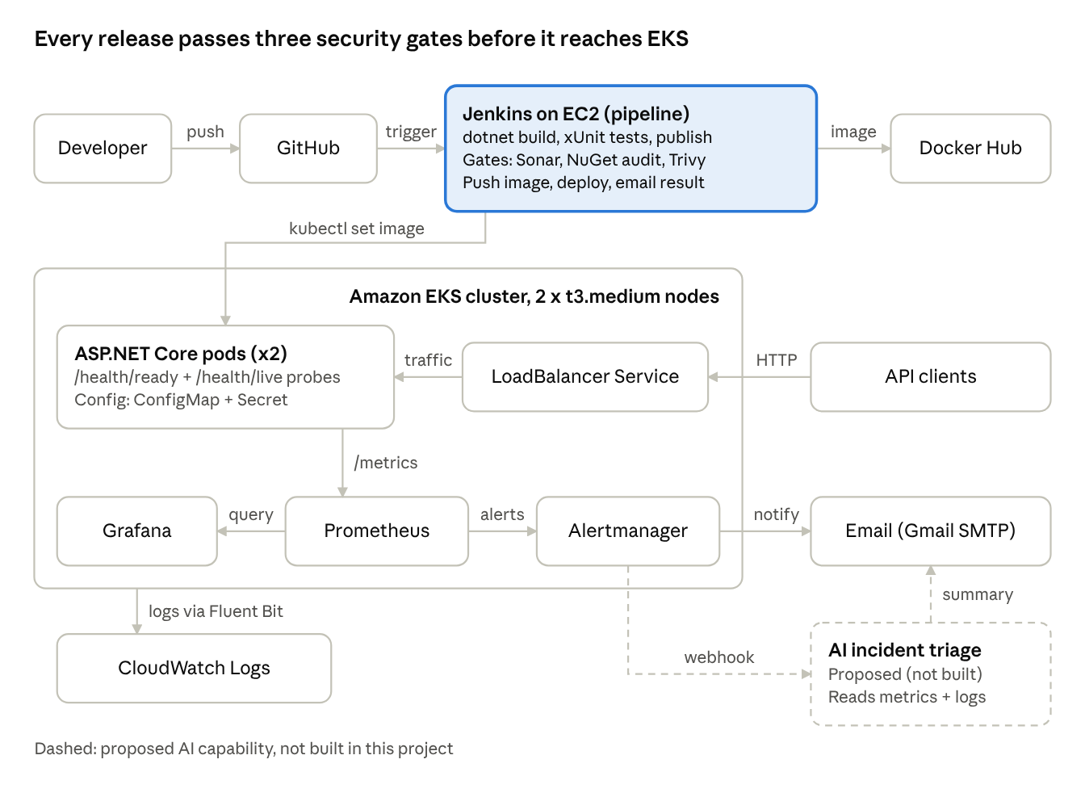
FinSecure Pay architecture (ASP.NET Core) · CI/CD, EKS, monitoring, proposed AI
Code flows left to right through Jenkins and its three gates into EKS; metrics, alerts and logs flow back out to Grafana, email and CloudWatch.
Redraw this in draw.io or PowerPoint for your submission.

7.2 Design document outline (3–5 pages)
- Introduction (½ page) — FinSecure Pay's problem, the goal of hands-off, repeatable deployment, scope.
- Architecture (1 page) — the diagram, then the flow in one paragraph: push → Jenkins → gates → Docker Hub → EKS → Prometheus/Grafana/Alertmanager → email; logs → CloudWatch.
- Tool choices and design decisions (1 page) — the substitution table from the Overview (ASP.NET Core, dotnet CLI/NuGet, xUnit, NuGet audit, prometheus-net) with one-line justifications; then multi-stage non-root Alpine image, EKS over self-managed Kubernetes, Jenkins on EC2 with an instance role, fixed version tags, maxUnavailable: 0, readiness vs liveness, managed logging over self-hosted ELK.
- Security considerations (½ page) — three gates and their thresholds, secret handling, namespace-scoped Jenkins access, non-root container, next steps (image signing, network policies, KMS-encrypted Secrets, private ECR registry).
- Recovery considerations (½ page) — two replicas, probes, self-healing, zero-unavailable rolling updates, automatic rollout undo on a failed deploy, manual rollback to any revision, alerting on replica loss.
- AI use case (1 page) — section 7.3.
- Lessons learned and future improvements (½ page) — section 7.5.

7.3 AI use case: AI-assisted incident triage
Problem. When an alert fires at night, the on-call engineer opens Grafana, reads logs from several pods, checks what was deployed recently and decides whether to roll back. In a small startup that takes 20–40 minutes and depends on who is on call. The signals are spread across metrics, logs and pipeline history; a language model can read that mixed text and numbers and write a short explanation, which a fixed script cannot do for every combination.
Inputs. The Alertmanager alert (name, labels, start time); the last 15 minutes of key PromQL series (reject rate, p95 latency, available replicas, CPU/memory); the last 200 application log lines and Kubernetes events for the namespace; the last three Jenkins builds (version, commit message, changed files, scan results); and the runbook. A prompt template asks for: most likely cause, evidence, confidence, and one recommended action from an allowed list (wait, roll back, scale up, page a human).
Integration. Add a second Alertmanager receiver (webhook) pointing at a small triage service — it could itself be a tiny ASP.NET Core minimal API or an AWS Lambda. It pulls the inputs through the Prometheus HTTP API, CloudWatch Logs Insights and the Jenkins API, masks account IDs, calls a managed model in-region (for example Amazon Bedrock), and adds the summary to the alert email. In phase 2 the email can carry an "approve rollback" link that triggers a Jenkins job running kubectl rollout undo; a human still decides.
Benefits. Faster mean time to recovery, a consistent first look whoever is on call, a written record for every incident, and quick spotting of "this started right after build #42".
Risks and governance. The model can be confidently wrong, so it only recommends — no automatic production action without human approval. Payment data must not leave unmasked; send masked IDs and aggregate metrics only, and keep the model in-region. Log every prompt and response for audit. Control cost by calling it only for firing alerts. Measure accuracy against post-incident reviews and switch it off if it is not helping.

7.4 Demo script (about 13 minutes)
- 0:00–1:00 — Business problem and the architecture slide.
- 1:00–2:30 — GitHub repo: C# code, xUnit tests, Jenkinsfile, k8s and monitoring folders; mention why .NET instead of Java.
- 2:30–5:00 — Push a small change; while Jenkins runs, walk through the stages; finish with rollout status and the new version on /health.
- 5:00–6:30 — Show the earlier failed-test build (deploy skipped) and the blocked Newtonsoft.Json build, then the fixed build.
- 6:30–8:00 — kubectl get pods, delete one pod, watch it return; rollout undo and show the old version.
- 8:00–11:00 — Grafana dashboard; start the bad-traffic loop a few minutes earlier so the alert is firing; show the email arriving.
- 11:00–12:00 — Logs: kubectl logs and a Logs Insights query.
- 12:00–13:00 — AI use case and lessons learned.
Record a backup video of each live step the day before in case EKS or email is slow on the day.

7.5 Lessons learned and future improvements (starter ideas)
- ASP.NET Core rather than classic MVC was the key decision that made Linux containers and EKS straightforward.
- Pin every image tag; rollback only works if the old tags are still in the registry.
- .NET starts in seconds, so short probe delays were enough; a JVM app would need longer ones.
- Dependency scanning for .NET works best with NuGet's own audit plus Trivy rather than OWASP Dependency-Check.
- Future: Terraform for EKS and the Jenkins host (reuse your earlier Terraform module), a Helm chart or Kustomize for the app, Argo CD for GitOps, canary releases, Cosign image signing, HPA autoscaling, a private ECR registry, OpenTelemetry tracing.

7.6 Slide plan (8–10 slides)
Slide | Content | Key evidence
1 | Overview and business problem | Repo link, Docker Hub link, scope
2 | Application and Git (+ why .NET) | Validation rules table, dotnet test results
3 | Docker and Kubernetes/EKS | Dockerfile, get pods, ELB /health
4 | CI/CD pipeline | Stage View green and red
5 | DevSecOps | Blocked build, vulnerable package, fix, Sonar gate
6 | Monitoring, alerting, logging | Grafana, firing alert, email, Logs Insights
7 | Architecture and AI use case | Diagram + AI triage flow
8 | Test results, recovery and rollback | Core test-case table (next section)
9 | Lessons learned and improvements | Bullets from 7.5
10 | Appendix | Extra screenshots, links
Crop screenshots so they are readable, and check none show a token, password or your AWS account ID before exporting to PDF.

Evidence checklist and teardown
Tick each core test case once you hold the screenshot; the table is also slide 8.
Core test case | How you show it | Guide step
Run unit tests | dotnet test and the Jenkins test report, all passing | 1.5, 4.4
Controlled failing test | Red Test stage, later stages skipped, old image still deployed | 4.4
Container /health | docker run + curl returns UP | 2.2
Two pods Ready | kubectl get pods 2/2 Ready | 3.3
New version rollout | rollout status + new version on /health | 4.4
Pod deleted and recreated | get pods -w output | 3.5
Security gate blocks release | NuGet audit fails on Newtonsoft.Json 12.0.3 | 5.2
Alert fires and notifies | Prometheus Firing + email received | 6.6
- ☐ Unit tests pass
- ☐ Failing test stops the pipeline
- ☐ Container /health works
- ☐ Two pods Ready on EKS, reachable via the ELB
- ☐ New version rolled out
- ☐ Rollback to a known-good version
- ☐ Pod recreated automatically
- ☐ Security gate blocked, then fixed
- ☐ Alert fired and email received
- ☐ Jenkins build email received
- ☐ Logs shown in kubectl logs and CloudWatch
- ☐ Facilitator confirmed the .NET alternative
- ☐ Design doc, slides, demo recording done
- ☐ Links (GitHub, Docker Hub) open in a private browser window
Teardown, once everything is captured (the GitHub repo and Docker Hub images stay up for the evaluator):
helm uninstall monitoring -n monitoring
kubectl delete namespace finsecure monitoring # removes the ELB too
aws eks delete-addon --cluster-name finsecure --addon-name amazon-cloudwatch-observability
eksctl delete cluster --name finsecure --region ap-southeast-1
# then terminate the Jenkins EC2 instance and delete the CloudWatch log groups
Check EC2 → Load Balancers and EC2 → Volumes afterwards to confirm nothing is left running.

